The Trials And Tribulations Of Tilted Tom

GDD Template Written by: Benjamin “HeadClot” Stanley

Special thanks to Alec Markarian

Otherwise this would not have happened

License

If you use this in any of your games. Give credit in the GDD (this document) to Alec Markarian and Benjamin Stanley. We did work so you don’t have to.

Feel free to Modify, redistribute but **not sell** this document.

TL;DR - Keep the credits section of this document intact and we are good and do not sell it.

Overview

Theme / Genre

Core Gameplay Mechanics Brief`

Targeted platforms

Project Scope

Influences (Brief)

- <Influence #1>

- <Influence #2>

The elevator Pitch

Project Description (Brief):

What sets this project apart?

Core Gameplay Mechanics (Detailed)

- <Combat >

- <Combo Spell Casting>

Gameplay

Gameplay (Brief)

Assets

- Graphical

- Sound

- Animation

# Overview

## Theme / Genre

Fantasy

2D Action dungeon crawler

## Core Gameplay Mechanics Brief`

- Dungeon Crawler

- Co-Op

- Magic Combos

- Puzzle Elements

## Targeted platforms

PC

## Project Scope

- <Game Time Scale>

- Time Scale – 1 Semester

- <Team Size>

3 Members

Harris Goudas

Haydon Simmons

Tom Malek

## Influences

### - <Influence #1>

The Legend Of Zelda: A Link To The Past

- This influence is used in the camera style and the puzzling elements that are used to progress through the story

### - <Influence #2>

Dark Souls

* Difficult gameplay and limited heals

## The elevator Pitch

A co-op dungeon crawler where you work with your friend to overcome great challenges, learn magic and defeat your foes.

## Project Description

The game is a single player or co-operative dungeon crawler where you fight off enemies with a sword and magic you learn along the way. Spells will be acquired through various challenges that will allow the player to progress in other areas of the dungeon. Each dungeon should be based around some sort of theme, music and level design will reflect this.

# What sets this project apart?

- The difficulty level

- Soundtrack

- The magic combo system

## Core Gameplay Mechanics (Detailed)

### - <Combat >

Player has a sword slash attack that is used to damage enemies.

Enemies who collide with the slash will take damage.

### - <Combo Spell Casting>

As the player progresses they will learn new spells which will be used to solve puzzles, aid allies, damage enemies, etc.

Player inputs the combo learned for the spell and then it will be performed. The spells are tied to a global cooldown.

# 

# Gameplay

## Gameplay (Brief)

Objective for the player is to clear the current dungeon floor. This includes finding the required spells and defeating enemies along the way.

# Assets

## - Graphical

- Environment sprites

- Player sprites

- Enemy sprites and particles

- Boss sprites and particles

- Spell sprites

## - Sound

- Sound List (Ambient)

- Level 1 floor music

- Level 1 boss soundtrack

- Sound List (Player)

- Character Hit / Collision Sound list

- Sword slash sounds

- Character on Injured / Death sound list

- a set of grunt sounds played at random

## - Animation

- Environment Animations

- Fade in/out animations

- Flashing boss room floor

- Character Animations

- Player

-Walking

-Attacking

- Bats

- Flame

- Flying

- Boss

- Vulnerable

- Invulnerable

Flowboard

Opening screen-with controls

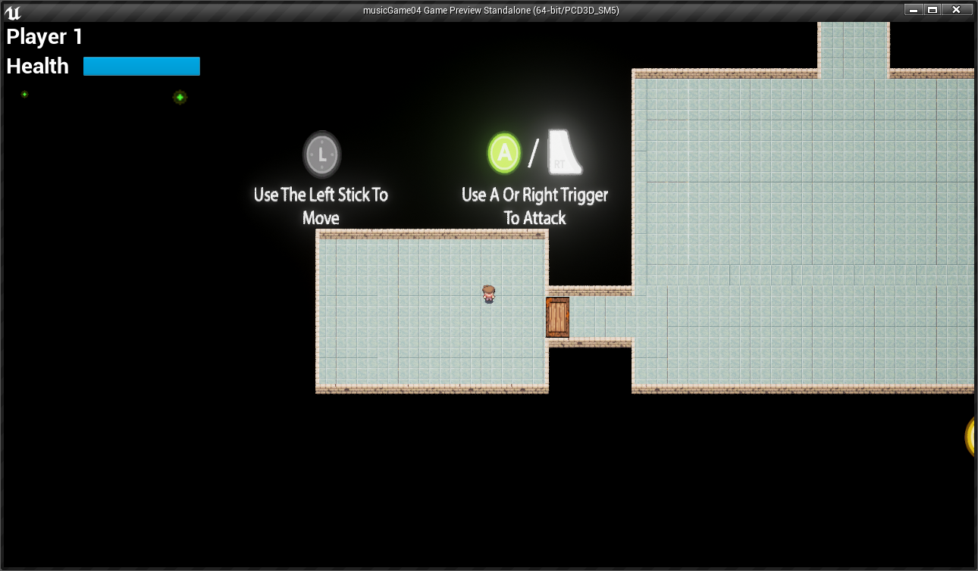

Enemies spawn on room entry- bats are invulnerable while on fire & and eye is blue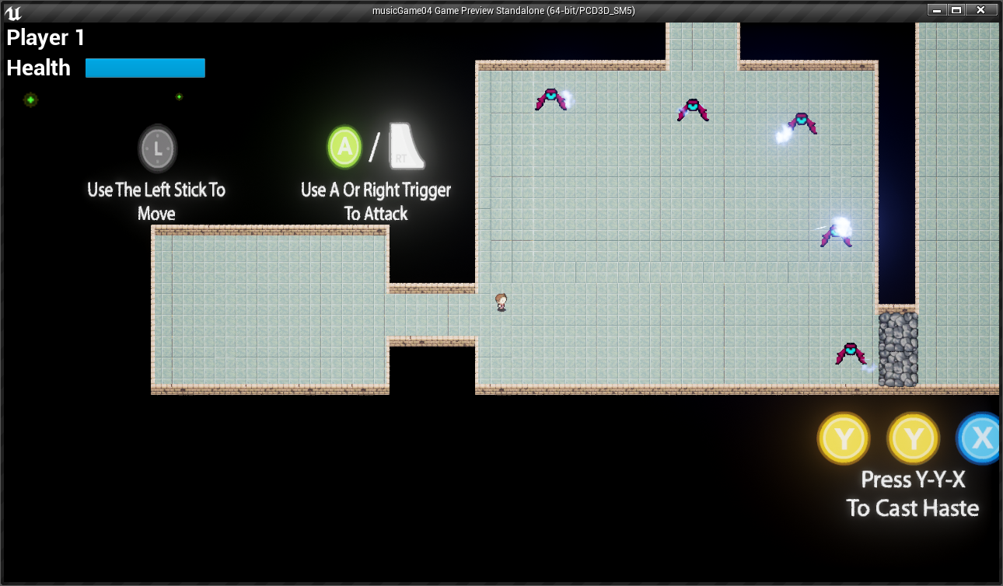

Can kill bats when their eye turns red after they charge at you

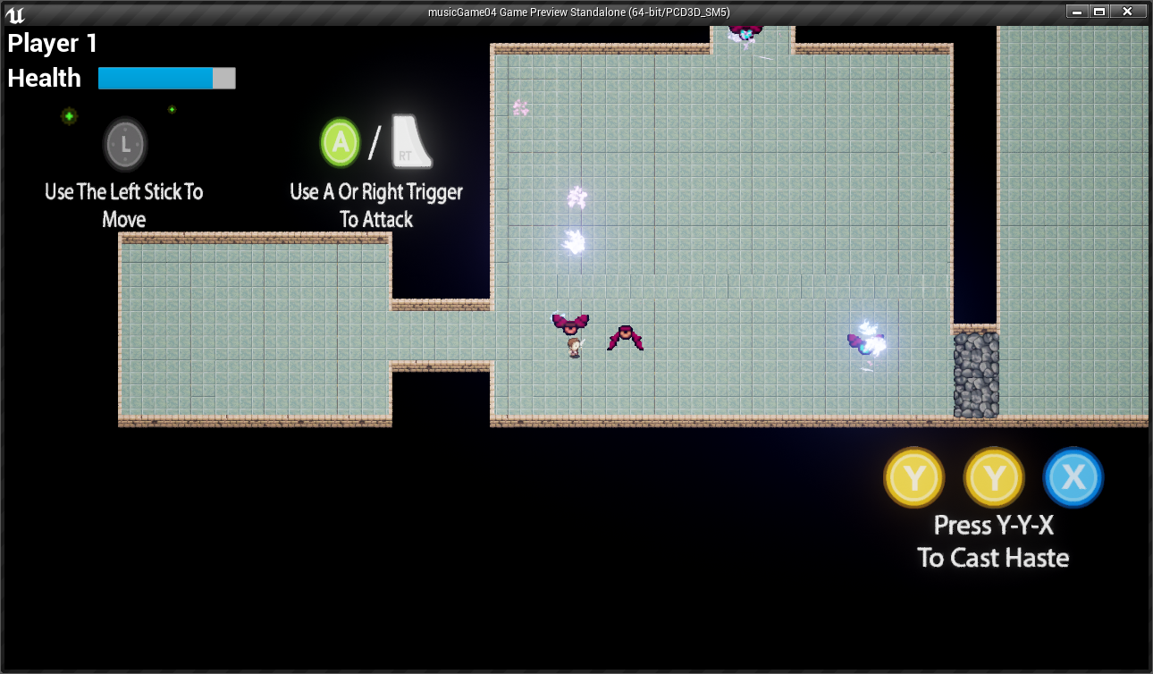

Rock wall on right disappears when all bats are dead

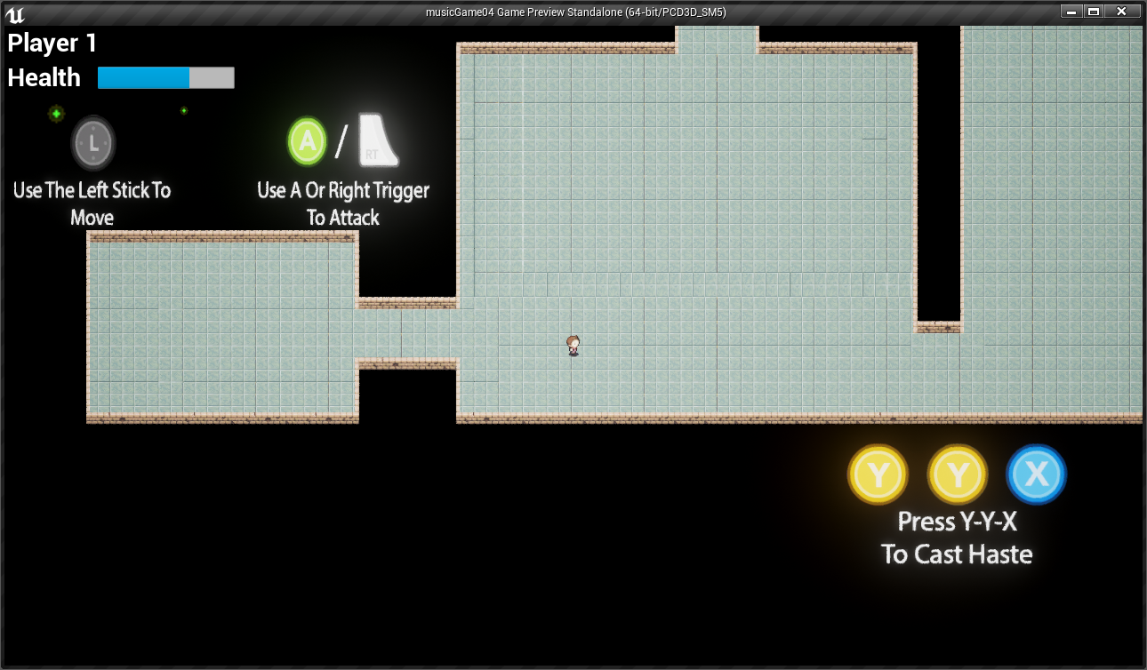

Can’t pass wood block

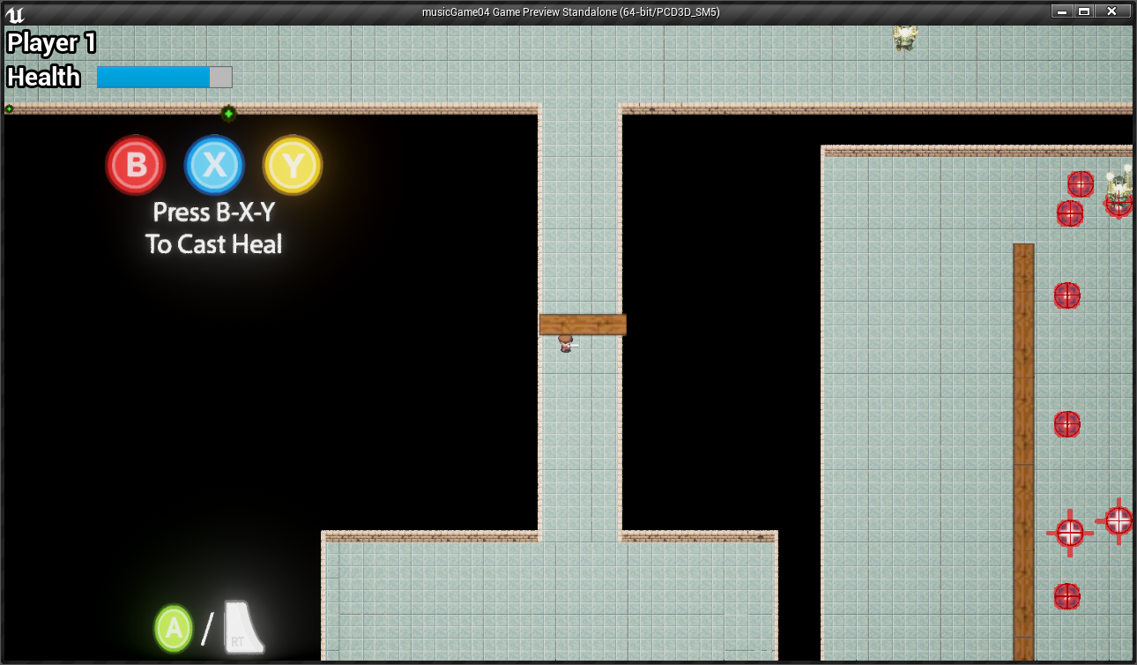

Collect book to learn fire spell

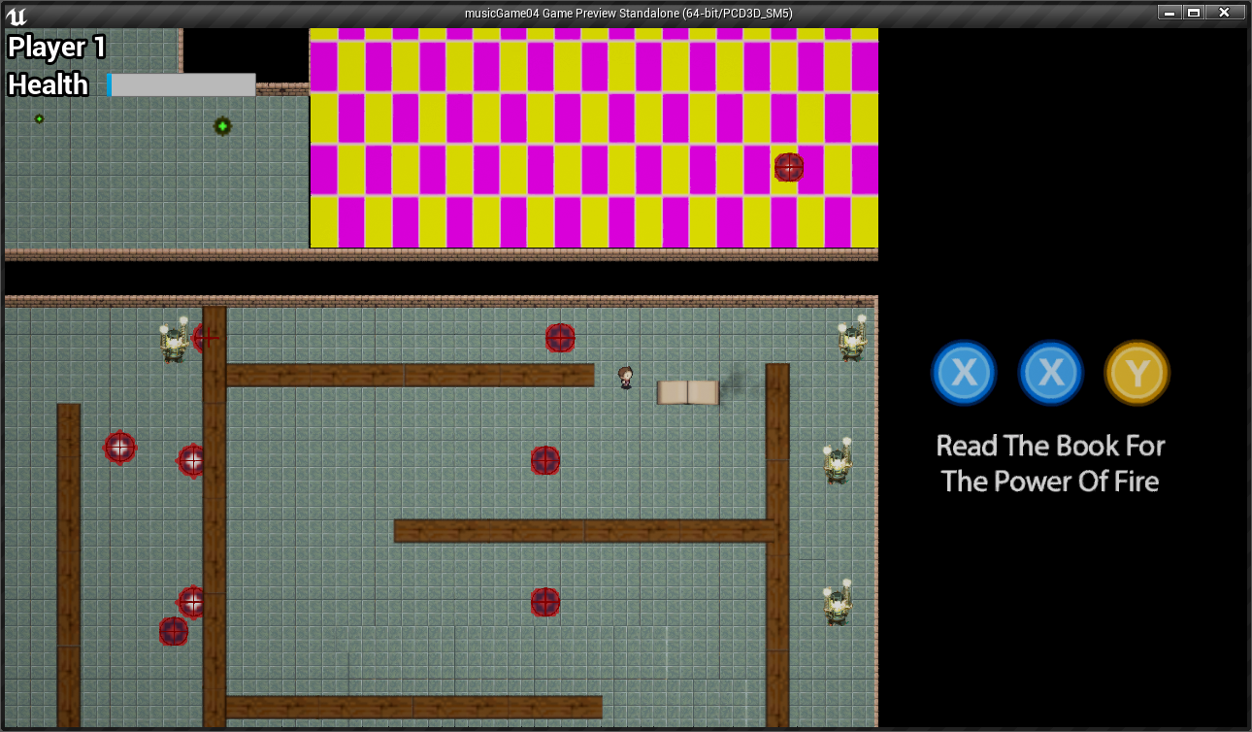

Use fire spell to burn wood blocks

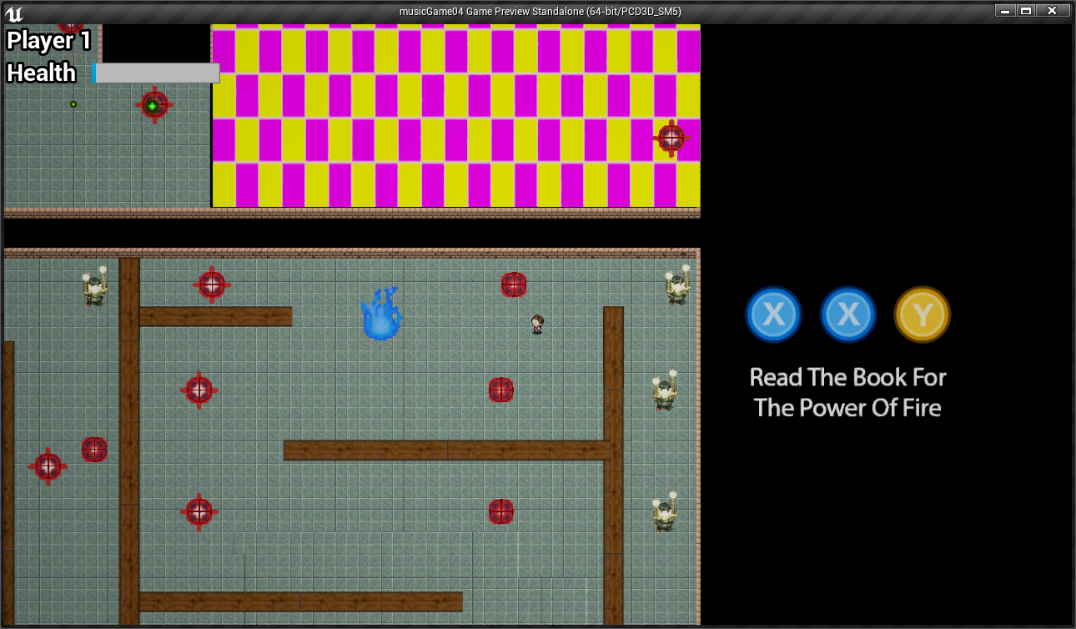

Burn down wood block

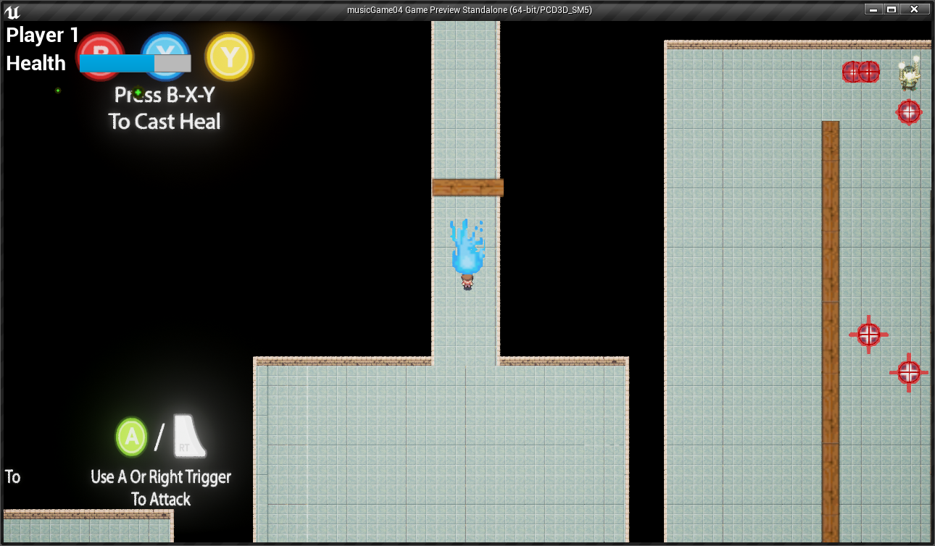

Boss doesn’t take damage while bats are alive

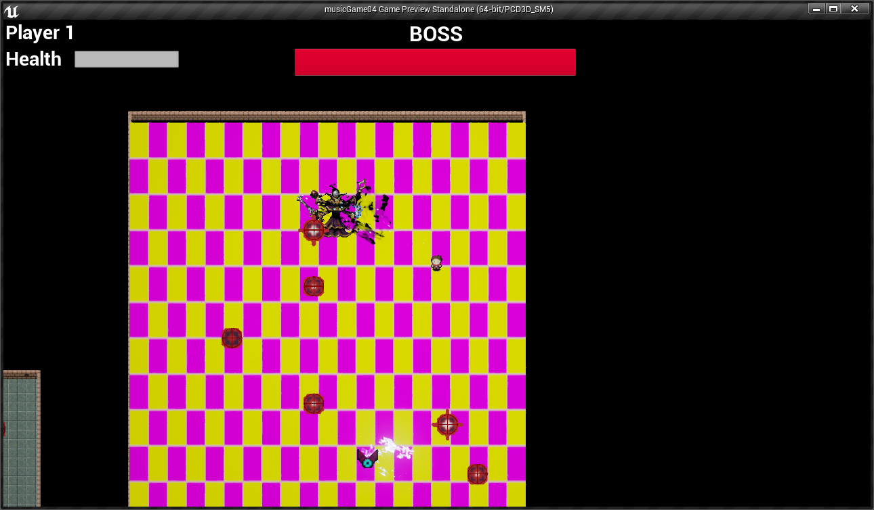

Boss does take damage while bats are dead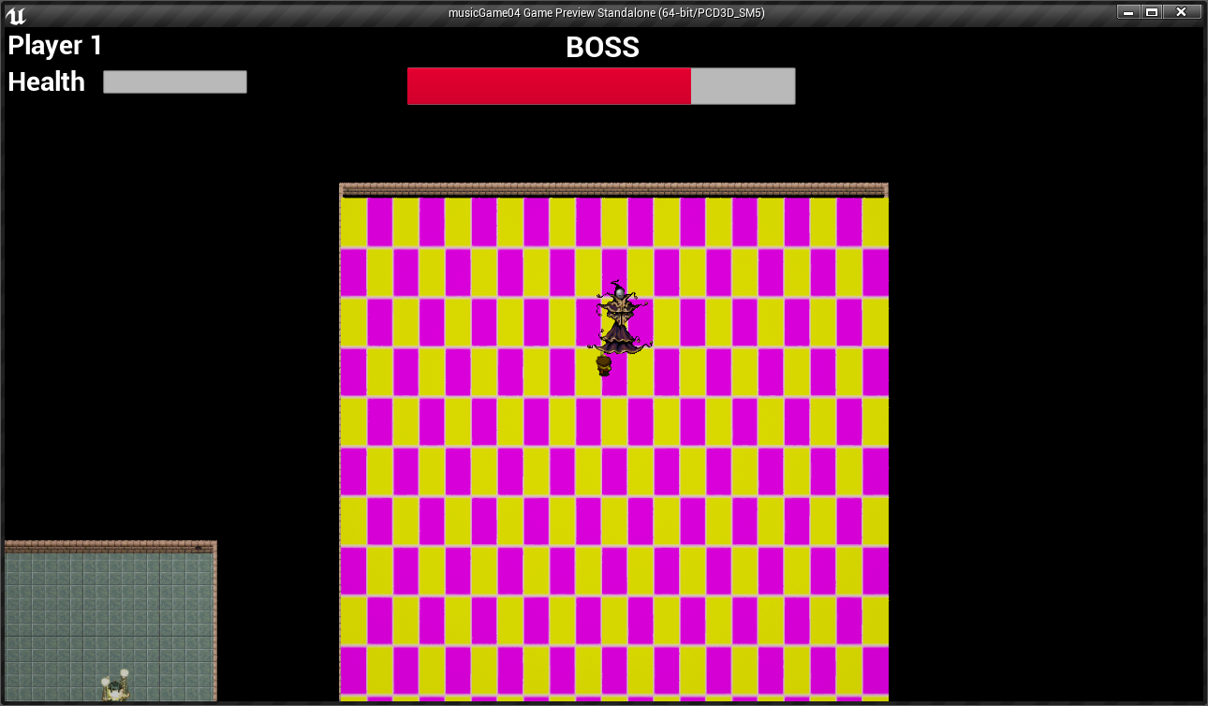

Boss is dead

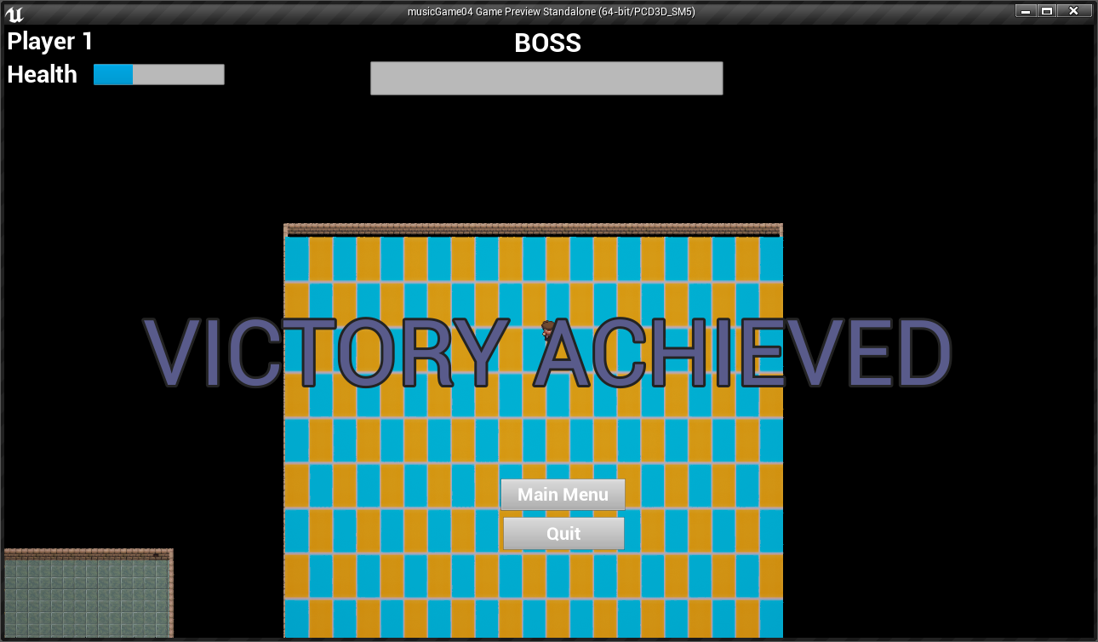

In case you didn’t make it that far

